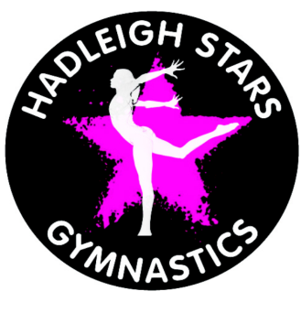
HADLEIGH STARS
GYMNASTS CODE OF CONDUCT
Gymnasts should always arrive on time. The warm up is the most important part of the session so you must be punctual at all times.
Gymnasts should always dress appropriately for class. The dress code is Leotards for girls and leotard and shorts for boys. Club leotards are available from the Club Coach
All long hair must be tied back neatly. No jewellery is to be worn in the gym.
Gymnasts must inform their coach of any injuries or illness, before warm up begins or as soon as it happens.
Gymnasts must never climb upon or use any equipment unless instructed to do so by a coach.
For their own safety gymnasts should follow the instructions of the coach at all times.
All members are expected to maintain a high standard of behaviour at all times.
Gymnasts who do not listen to the coach, misbehave or are disruptive will be asked to sit out of the session. This is for the safety of the gymnasts as well as other participant. Parents will be notified if appropriate. Continuous and poor or disrespectful behaviour towards coaches or other gymnasts. Or the breaking of the Code of Conduct will not be tolerated. Those concerned may be suspended or asked to leave the club permanently.
Bullying will not be tolerated and any child persistently bullying will be suspended and may be asked to leave the club permanently.
Gymnasts must not leave the gym during session under any circumstances without permission from the coach. At the end of the session gymnasts must ensure that their parent/guardian has signed them out. Gymnasts over 12 may sign themselves out so long as their parent/guardian has given the Club permission. This if for your safety!
Failure to atten training on a regular basis may result in the member losing their place.
All discipline matters or complaints should be directed to the Session Coach in the first instance, thereafter the Head Coach or Welfare Officer

