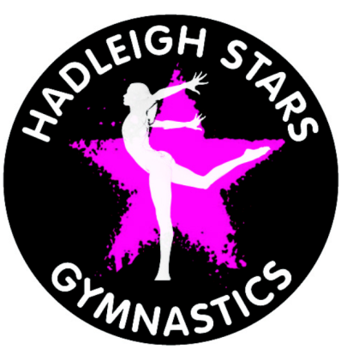
Hadleigh Stars
Gymnastics

CHILD PROTECTION POLICY

Hadleigh Stars Gymnastics is committed to ensuring that those working with children and vulnerable adults adopt the best possible practice to ensure the health, safety and welfare of the participants and staff.

We will endeavour to promote the highest standards of care for all members, staff and officials by:-

- The adoption of British Gymnastics Health, safety and welfare guidelines.

- The adoption of British Gymnastics guidelines for the protection of children and vulnerable adults.

- The appointment of a Welfare Officer to whom grievances or complaints can be made confidentially.

- Ensuring that coaches and officials have been screened to confirm their suitability to work with children. This will include criminal record disclosure if appropriate.

- Ensuring that the best coaching practice guidelines are followed at all times.

- Ensuring that grievances or complaints are dealt with promptly and in accordance with the grievance procedure.

- Ensuring that there are a minimum of two responsible adults at all training sessions.

- Ensuring that the participants and parents are aware of the purposes of videoing, filming or photography during training or events.

- Having a zero tolerance level of poor practice, bullying or any other potential form of abuse.

Club Leader’s name:

Signed:

Date:

